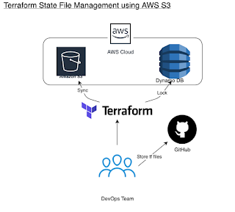

**How to store Terraform state file in S3 Bucket | How to manage Terraform state in S3 Bucket**